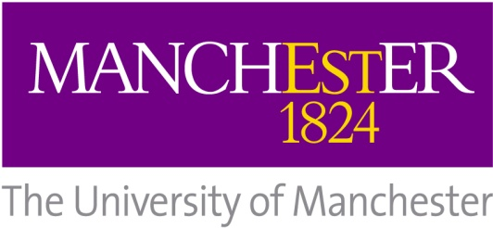

MRC Advanced Course masters studentships 2015/16
MRes Translational Medicine (Interdisciplinary Molecular Medicine)

Please note that this application form should be submitted alongside a formal application for the MRes in Translational Medicine (Interdisciplinary Molecular Medicine). Formal applications can be submitted online:
http://www.manchester.ac.uk/postgraduate/howtoapply/
This form should be submitted by UK/EU* candidates wishing to be considered for a MRC Masters Studentship in order to financially support themselves on the programme. MRC studentships provide an annual tax-free maintenance stipend (as a guide, the minimum 2014/2015 rate is £13, 863) in addition to covering tuition fees. Applicants must have been permanent residents of the UK since at least 1 September 2012 in order to be considered for full funding.
Name:

Academic Qualifications:
Undergraduate Degree (or equivalent) and grade:

Awarding Institution and year:

Masters Degree (if applicable) and grade:

Awarding Institution and year:

Nationality:

Supporting statement:

Please summarise (in no more than 500 words) your reasons for applying for the MRes, what attributes you bring to the course, what relevant laboratory research experience you have, what you hope to achieve from the programme and your career plans following completion:

Please submit this form at the same time as submitting an online application for the MRes.
There is no need for applicants for MRC studentships to submit a second statement of purpose.

Applications must be submitted no later than 30 June 2015 with early application advised as studentships may be allocated in advance of this.

*Applicants for MRC studentships must be UK/EU nationals who have been permanent residents of the UK since at least 1 September 2012. EU nationals who do not meet the UK residency requirement are eligible for studentships providing tuition fee support only. Please direct any eligibility enquiries to Dr Janine Lamb at the address above.

